**1. What do you mean by AutoComplete feature in Excel and what are the**

**benefits of using this feature?**

AutoComplete helps you quickly insert functions and arguments while minimizing typing and syntax errors. The AutoComplete menu shows you available options based on context, and you choose what you want to insert into your formula.

**2. Explain working with workbooks and working with cells.**

A workbook is a file that contains one or more worksheets to help you organize data. You can create a new workbook from a blank workbook or a template.

The cells are organized into columns and rows. A worksheet is always stored in a workbook.

**3. What is fill handle in Excel and why do we use it?**

Fill Handle in excel is used to fill up the data by creating a series of value that either follows a pattern or check if the values we entered are of series. It is very easy to implement. Fill Handle is available at the right bottom of any cell. Enter some values such as numbers or alphabets, or dates in at least 3 cells to have a pattern. Select the cells with values and then either drag the Fill Handle or double click will also work here.

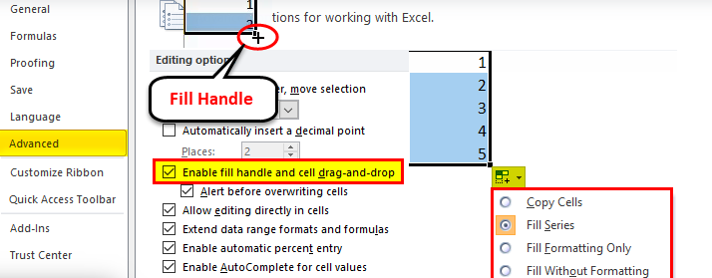

**4. Give some examples of using the fill handle.**

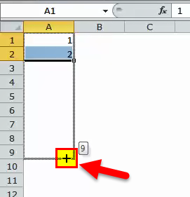 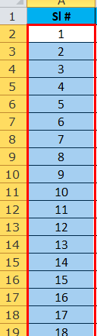

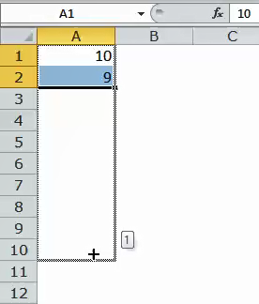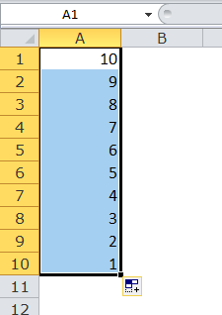

**5. Describe flash fill and what the different ways to access the flash fill are.**

Data > Flash Fill and Excel automatically fills in your data.

You can go to Data > Flash Fill to run it manually, or press Ctrl+E. To turn Flash Fill on, go to Tools > Options > Advanced > Editing Options > check the Automatically Flash Fill box.

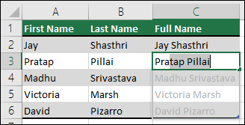

**6. Extract first name and last name from the mail id and then from the**

**address column, extract the city, state, and pin code using the flash fill.**

**Given below is an example of the columns you have to create. Paste the**

**screenshot of what you have created using the flash fill command.**

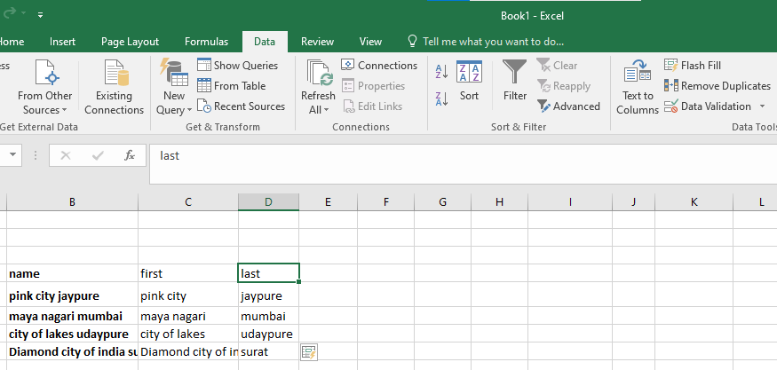

From right hand side first Flash fill.